Authors’ Responses to Editors and Reviewers

Dear Editor in Chief;

Thank you very much for arranging the review for our paper and kindly giving us the opportunity to revise our Manuscript entitled “An Overview of Artificial General Intelligence: Recent Developments and Future Challenges” We appreciate your high efficiency in handling our manuscript and your efforts on matching reviewers for our manuscript. The Reviewers’ comments are accurate, convincing, helpful, and enlightening in improving the quality and originality of our manuscript. We like to accept and follow all of their comments and suggestions.

We wish the revised manuscript could meet the standard of “Journal of Computer Science”. If the modifications are not qualified, please give us an opportunity to do further revisions.

Our point-to-point responses to the Reviewers’ comments are presented as follows.

Please feel free to contact us for any further questions.

Thank you again for your time and kind help.

Best wishes,
Responses to Reviewer #1
- Introduction can be extended by highlighting the contribution of the study. Gaps of the literature and gaps of previous literature review studies.
Thank you for your valuable comment. In this section, We added contribution of the study and Gap in literature
Contribution of the Study
In this study, we review the historical development of artificial general intelligence, artificial intelligence, machine learning, and data science. We compare these developments with the human intelligence and abilities. Also, the research looks at future possibilities in artificial general intelligence (AGI), while analysis ethical dilemmas posed by future evolutions. The focus of the study is to analyze the evolution processes historically and in the future for a lay man's better understanding of artificial general intelligence and data science.
Gap in literature
There have been many literatures analysis the artificial general intelligence advancements. However, very little has been covered to analyse Deep Learning (DL) as a technological evolution. It is essential to note that the advancements of DL is a vast topics in and of themselves, each carrying with them a many relevant subjects.
2 - In introduction, a brief section should be added to review applications of artificial intelligence in different applications and meta-heuristics algorithms
Application of Artificial General Intelligence
AG is applied in many instances, it has been adapted to complement our everyday lives. In this case, we look at machine learning (ML). Machine Learning techniques and data sets can be classified in two groups, that is, linear and nonlinear (Vita-More, 2020). A linear data pattern is not complicated which can be further grouped using linear function to perform classification. Multiple algorithms have been established to fit many linear regressions, logistic regression, classification and regression trends, and anchor vector machine. Nonlinear functions algorithms cannot be grouped using linear methods. Similar to other methods of analysing data and management, nonlinear data associations may offer more challenges to ML.
Although multiple algorithms have been established to perform linear data, the nonlinear nature of most data sets still pose a challenge for ML. For instance, the decision trees, k-nearest neighbours, and anchor vector machine. This research paper entails literature review, methodology and results, recommendations for future research and conclusion.
3 - Literature section should be put in a structured way. With current form, it is hard to follow up now
Response: Thank you for your valuable comment. I have re-arranged the literature review according to date of artificial general intelligence to enhance flow.
4- Methodology can be shown better. Maybe a flowchart can be drawn to show the methodology.
Response: To respond to this comment, I used a diagram for better illustration.
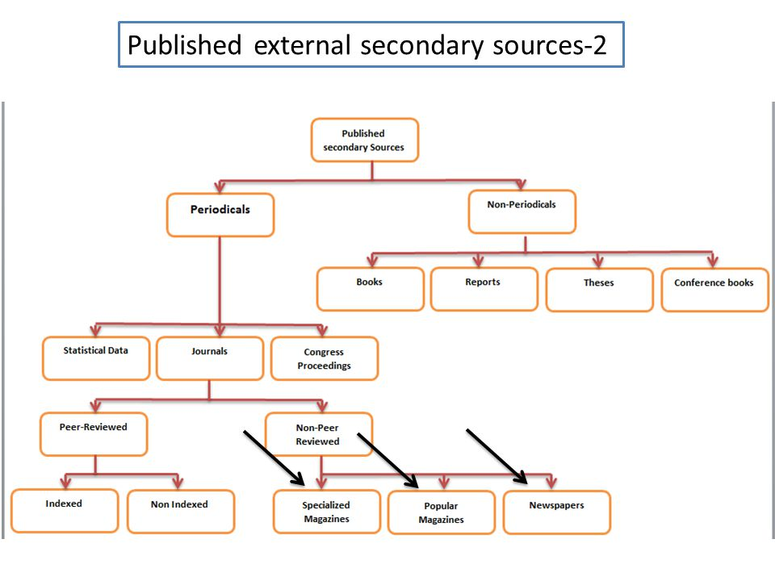

5- Discussion should address further research directions and what can be done in future to address research gaps.
Recommendations and Future Direction
There is a need for the utilization of AG in the generalization of human cognitive abilities. In this regard, when the AI systems are faced with challenging tasks, the AGI framework will be more oriented to tackling without much difficulty. Examples of such systems will include self-driving cars with expert supercomputers. Making AGIs as smart as humans will require the customization of AI-based bots to enable real-time monitoring for marketing processes; thus, the AGU frameworks will replicate overly similar intelligence. The future direction should also underlie the usage of AGI systems in the personification of human tasks. In this regard, the smart AI-powered bots can imitate human thoughts and dreams, especially for the future. As a result, the AGI systems can be used to comprehend human-robot interactions.
Responses to Reviewer #2

1-In recent years, AI has undergone many changes, and major progress
in key domains such as vision, language, control, etc., have been
made. Since this paper is an overview paper, more papers published in
recent years must be considered in the revised version of the
manuscript.
Thank you for the valuable comment. To add to the publications used, we added these citations.
Almeida, P., Santos, C., & Farias, J. S. (2020, January). Artificial Intelligence Regulation: A Meta-Framework for Formulation and Governance. In Proceedings of the 53rd Hawaii International Conference on System Sciences. http://128.171.57.22/handle/10125/64389
Arbital. (2015). Value. Retrieved November 4, 2020, from arbital.com website: https://arbital.com/p/value_alignment_value/
Vita-More, N. (2020). WISDOMAS META-KNOWLEDGE: A PRACTICAL APPLICATION OF ARTIFICIAL GENERAL INTELLIGENCE AND NEURAL MACROSENSING. The Age of Artificial Intelligence: An Exploration, 291. https://books.google.com/books?hl=en&lr=&id=eEvXDwAAQBAJ&oi=fnd&pg=PA291&dq=Application+of+Artificial+General+Intelligence&ots=ldNFbHdEoy&sig=irQo_nso_uHCo_eU93wyhccGHBM
Yudkowsky, E. (2011, August). Complex value systems in friendly AI. In International Conference on Artificial General Intelligence (pp. 388-393). Springer, Berlin, Heidelberg. https://link.springer.com/chapter/10.1007/978-3-642-22887-2_48

- The proper reference to the hypothesis proposed in the subsection titled "Principles of the grouping of theories" is required. Also, the authors would provide more explanation on how these hypotheses are used in this study.
Principles of the grouping of theories
1) Explanation of the complexities of values (not the multifaceted nature of the hypothesis): Certain speculations of human qualities suggest that human qualities are exceptionally straightforward, for example that the urges are two: endurance and generation; or that there is just one ability to optimize pleasure; or that there are only nine essential feelings (Almeida et al., 2020). Other ideas show that human beliefs, such as a continuum of interaction between all meanings and incentives, are complex.
2) The degree of "behaviorism": many ideas are drawn from either of the poles: "supporter of internalism" thesis which believe that virtues are present and are suppressed within mankind wit, together with "behaviorist" thesis that suppose that values are manifested in an individual’s behavior. The principles and process concerning their believe (e.g. approval-directed AGI) are combined by behaviorist theories of human values (generally). On the other hand, internist ideologies usually hold that beliefs exist independently from the way they are studied.
According to the abstractness level, another way to describe hypotheses regarding human beliefs is certain theories may be generalized to a conceivable mind and in this manner don't take contribution from human brain research or neurophysiology (Almeida et al., 2020). These hypotheses are computationally abstract and can also contain implicit beliefs concerning some of the human mind's properties: equilibrium, harmony, continuity, etc. Human-centred theories depend on established human-minded theories. So there is a research question in this paper: What is the future in the development of emotional intelligence in artificial intelligence?
Almeida, P., Santos, C., & Farias, J. S. (2020, January). Artificial Intelligence Regulation: A Meta-Framework for Formulation and Governance. In Proceedings of the 53rd Hawaii International Conference on System Sciences. http://128.171.57.22/handle/10125/64389

- Since the methodology used in this study does not need quite a bit of explanation, as a suggestion, two sections, namely, results and methodology could be merged. Also, please be specific on how you choose the segment of the data to explain the presented narratives effectively.
Thank you for your valuable comment. We merged methodology and results. Moreover, in the diagram, we listed specific segments where we drew the data.
3. Methodology and Results
The study's approach was qualitative, and as a result, data was primarily dependent on literature by specialists in the AI spectrum. The analyzed literature was sourced from peer-reviewed articles on technology and the ethics and future of AI. A segment of the data was presented in graphs to explain the presented narratives effectively.

- the word defense on page 1 line 6 and page 2 line 2 is misspelled, review all the paper to avoid such misspellings.
Thank you for this correction, we revised the spelling of defence to defense.
Responses to Reviewer #3
The present study aimed to investigate the relationship between AI and the emotive quotient of human beings using a qualitative method. The research gap is worth studying; however, the paper should be improved, considering the following comments.
1. The contribution of the paper is not clear. It would be best if you clarified the contribution of the paper in the introduction section. Also, the research question is too general. It is better to have some detailed questions, not a general question.
Thank you for the valuable comment. We have responded to it at Response #1 (1)

2. There is no reference for the “Principles of the grouping of theories” section. Please cite some up to date research
Thank you for the valuable comment. We have responded to it at Response #2 (1)
3. The structure of the paper should be addressed at the end of the introduction.
This research paper entails literature review, methodology and results, recommendations for future research and conclusion.
4. In the first paragraph of the literature review, the authors have mentioned some quotations, while there is no reference for them. You should cite related papers in which “Yudkowsky” expressed his ideas.
Yudkowsky, E. (2011, August). Complex value systems in friendly AI. In International Conference on Artificial General Intelligence (pp. 388-393). Springer, Berlin, Heidelberg. https://link.springer.com/chapter/10.1007/978-3-642-22887-2_48

5. A more comprehensive methodology is needed. The methodology should be written in such a way that other scholars can follow it. You should provide your research steps. What is the research method, and how it fits the research gap? Data collection should be explained.
The study's approach was qualitative, and as a result, data was primarily dependent on literature by specialists in the AI spectrum. The analysed literature was sourced from peer-reviewed articles on technology and the ethics and future of AI.
6. A more comprehensive conclusion is needed. It would be better if the authors merge “conclusion” and “Recommendations and Future. Direction” and explain how the results can answer the research question(s). On top of that, research limitations should be addressed
in the conclusion section.
Thank you for your valuable comment. We merged conclusion and recommendations and future directions as directed. We also included the research limitations in the conclusion section.
Research Limitations
This research paper used secondary published data as the main source of information. The information corrected may not be very accurate as when a primary source is used. Also, the sample used in the secondary data is small and limited.

